Cyclic Dependency in Spring Boot

What is Cyclic Dependency?
A cyclic (circular) dependency happens when two Spring beans depend on each other for creation.
Bean A → needs Bean B
Bean B → needs Bean A
Spring cannot decide which one to create first.
This is not a runtime problem — it is a startup-time failure.

How It Happens Internally
Spring creates beans like this:
- Create Bean A
- Inject dependencies into Bean A
- If Bean A needs Bean B → create Bean B
- If Bean B needs Bean A → create Bean A again
- Spring detects a loop → throws exception
This is why circular dependencies crash applications before the server starts.

Real Code Example (Problem)
StudentController
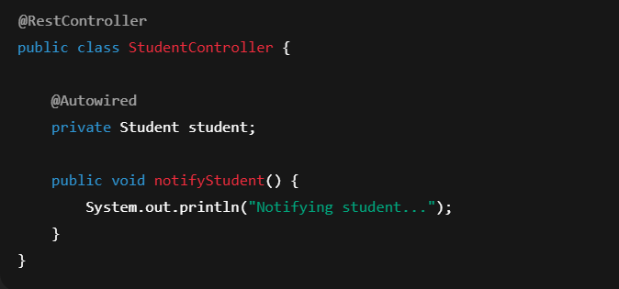
Student
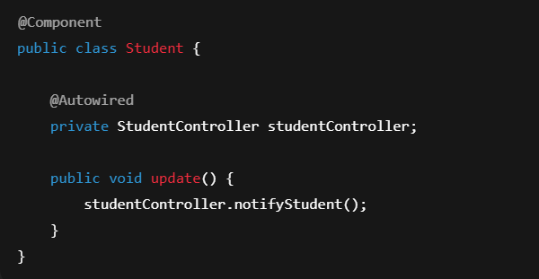
What Spring sees

This forms a cycle.
Spring throws:
BeanCurrentlyInCreationException

🔧 Fix 1 — @Lazy Injection
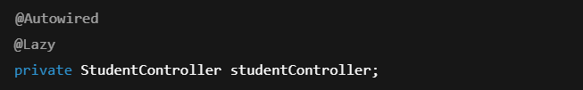 What really happens here?
Spring does NOT inject the real StudentController.
It injects a proxy object instead.

That proxy:
• Looks like StudentController
• Does nothing until a method is actually called
So Spring can:
- Create Student
- Inject proxy
- Create StudentController
- Later replace proxy with real object
This breaks the creation loop.
⚠️ But the design is still wrong — only delayed.

🔧 Fix 2 — Setter Injection
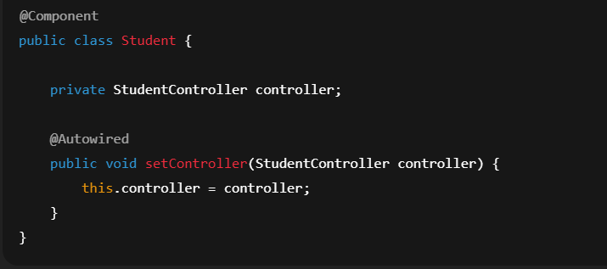
Why this works
Spring can:
- Create both objects first (without wiring)
- Then inject dependencies afterward
This avoids circular construction.
Better than @Lazy, but still not ideal.

🔧 Fix 3 — allow-circular-references (Worst)
Add the below line in Application Properties file
Spring will force the app to start —
but the design problem still exists.
Never use this in real systems.

🔧 Fix 4 — Correct Design (Best Practice)
Move shared logic into a Service.
StudentService
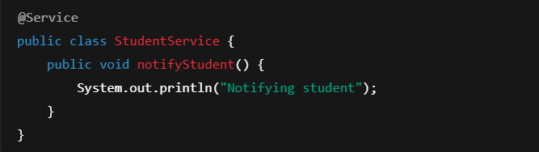
StudentController
 Student
 Now:
- Controller → Service
- Student → Service
- No circular reference
This is how real enterprise applications are built.

🎯 Interview Gold Line
“Circular dependency happens when two beans depend on each other during creation. It should be solved using better design, not configuration tricks.”

